**WEEK 8**

create database flight;

use flight;

create table flights(

flno int,

from_ varchar(20),

to_ varchar(20),

distance int,

departs time,

arrives time,

price int,

PRIMARY KEY(flno)

);

create table aircraft(

aid int,

aname varchar(20),

cruisingRange int,

PRIMARY KEY(aid)

);

create table employee(

eid int,

ename varchar(20),

salary int,

PRIMARY KEY(eid)

);

create table certified(

eid int,

aid int,

FOREIGN KEY(eid) REFERENCES employee(eid) on update cascade on delete cascade,

FOREIGN KEY(aid) REFERENCES aircraft(aid) on update cascade on delete cascade

);

insert into employee values(101,'Avinash',50000);

insert into employee values(102,'Lokesh',60000);

insert into employee values(103,'Rakesh',70000);

insert into employee values(104,'Santhosh',82000);

insert into employee values(105,'Tilak',5000);

insert into aircraft values(1,'Airbus',2000);

insert into aircraft values(2,'Boeing',700);

insert into aircraft values(3,'JetAirways',550);

insert into aircraft values(4,'Indigo',5000);

insert into aircraft values(5,'Boeing',4500);

insert into aircraft values(6,'Airbus',2200);

insert into certified values(101,2);

insert into certified values(101,4);

insert into certified values(101,5);

insert into certified values(101,6);

insert into certified values(102,1);

insert into certified values(102,3);

insert into certified values(102,5);

insert into certified values(103,2);

insert into certified values(103,3);

insert into certified values(103,5);

insert into certified values(103,6);

insert into certified values(104,6);

insert into certified values(104,1);

insert into certified values(104,3);

insert into certified values(105,3);

insert into flights values(1,'Bengaluru','NewDelhi',500,'06:00','09:00',5000);

insert into flights values(2,'Bengaluru','Chennai',300,'07:00','08:30',3000);

insert into flights values(3,'Trivandrum','NewDelhi',800,'08:00','11:30',6000);

insert into flights values(4,'Bengaluru','Frankfurt',10000,'06:00','23:30',50000);

insert into flights values(5,'Kolkata','NewDelhi',2400,'11:00','03:30',9000);

insert into flights values(6,'Bengaluru','Frankfurt',8000,'09:00','23:00',40000);

select * from employee;

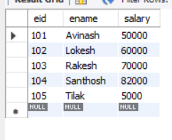

select * from aircraft;

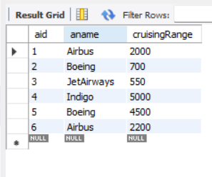

select * from certified;

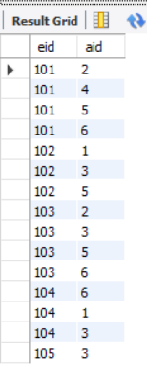

select * from flights;

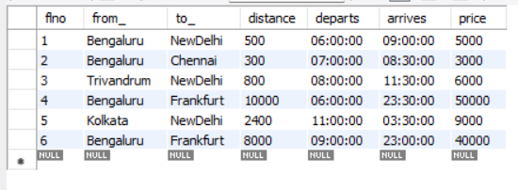

**TO DO:**

**1**

select (a.aname) from employee e inner join certified c

on e.eid=c.eid and e.salary>80000 inner join aircraft a on a.aid=c.aid;

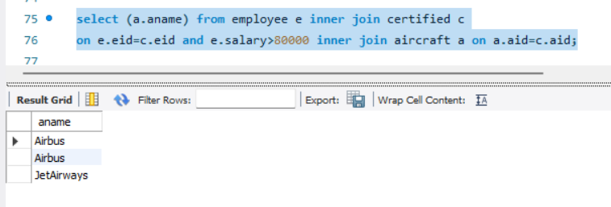

**2.**

select c.eid, max(a.cruisingRange)

from aircraft a, certified c

where c.aid=a.aid group by c.eid having count(*)>=3;

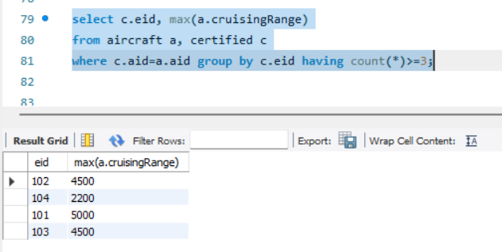

**3.**

select ename from employee where salary<some(select price from flights where from_='Bengaluru' and to_='Frankfurt');

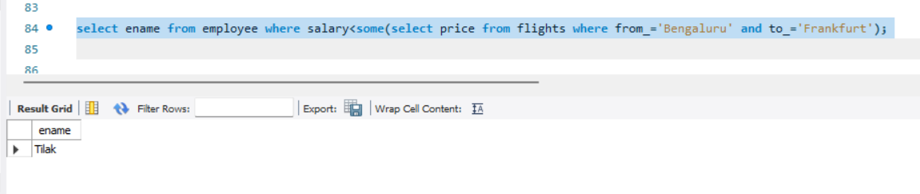

**4.**

select c.aid,a.aname, AVG(e.salary) from certified c, aircraft a, employee e where a.cruisingRange>1000 and e.eid=c.eid and a.aid=c.aid group by c.aid ;

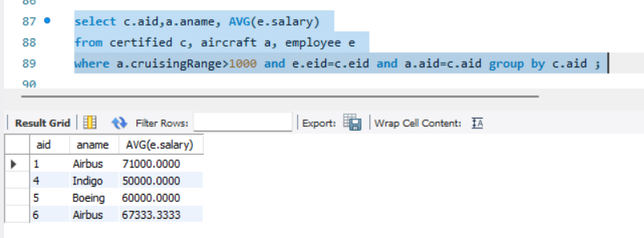

**5.**

select distinct e.ename from employee e, certified c, aircraft a where a.aid=c.aid and e.eid=c.eid and a.aname='Boeing';

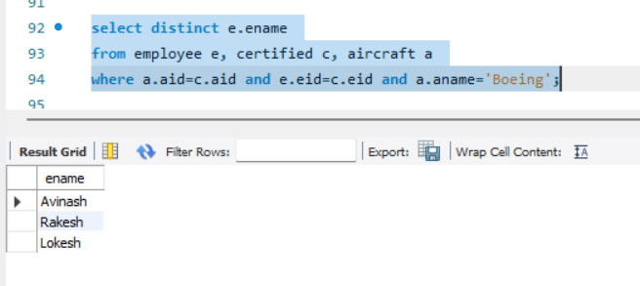

**6.**

select a.aid from flights f, aircraft a where (f.from_='Bengaluru' and f.to_='NewDelhi') and f.distance<=a.cruisingRange;

